OpenChrom 1.3 Manual
Created by Dr. Shaoyang Liu
This work is licensed under a Creative Commons Attribution-ShareAlike 4.0 International License.
Install Java runtime environment (JRE) before use.

- Get window layout ready
a) Click “demo” tile on the welcome page. Then, load the data and close the demo data.
Or, b) Click “Window” >> >> select

- Open data file
Click “File” >> for FID or similar signal
Click “File” >> for Mass
Or
Use 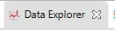 in the upper left view in the “data analysis” perspective

- Basic operations
Enlarge chromatogram: Left click and hold to draw a rectangle to define the range on the chromatogram view (upper right).
Double click on the chromatogram: select a mass scan (marked as x). The scan’s mass spectrum is shown in the view (lower middle). Ions are listed in the view (lower right).
Add a view: Click on in the quick tool bar on top. Type key work(s) in the top bar to search related views.
Change perspective: Click on in the quick tool bar on top.
Important Note: if you perform processing steps while you have zoomed into the chromatogram, the processing will only affect the current retention time window.
Right click on the chromatogram view: context menu shows related operations of the chromatogram. Filters include “Denoising”, “Ion remover”, “Scan remover”, et al (sometimes, not working). (Sometimes, the context menu doesn’t work.)
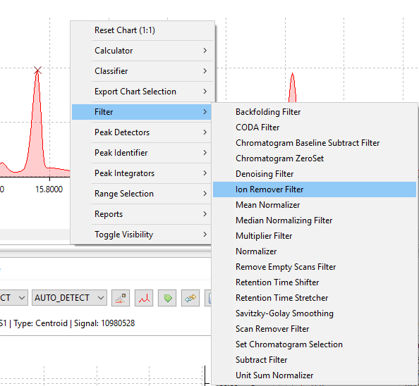

Process chromatogram: You also can go to “Chromatogram” menu:
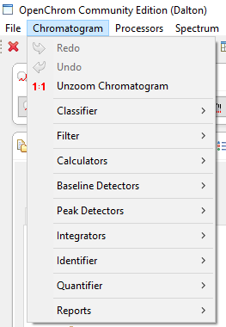
Go to Window >> Preferences to set parameters of operators before use (some operators can be used with default setting).
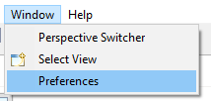
- Optimize chromatogram (optional)
Go to Chromatogram >> Filter
Can smooth chromatogram, denoise, subtract, shift retention time …

- Define baseline (optional)
Click “Chromatogram” >>
typically works fine. Since it only works in the selected chromatogram range, typically full chromatogram should be shown in the “Chromatogram” view (upper right). Baseline can be reviewed in the chromatogram view and view (lower middle).

- Peak detection
- Automatic peak detection
Go to “Chromatogram” >>
There are two detectors:
1) is the basic one.
2) may work better on overlaid peaks.
- Manual peak detection
Click on “Toggle the peak(s) modus” in the Task Quick Access window on top.
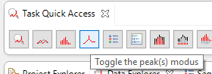

view will show up in the lower middle window. (Note: You have to click the “Toggle peak(s)” button in the Quick Access window first, or the “Peak Detector” view won’t show up in the “select view” list.)
To add a peak:
    - Select a chromatogram range

    - Select a Modus 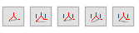. To draw a baseline of a peak, select baseline modus (), hold “Ctrl” key, left click, hold and drag to draw the baseline. Then, release the “Ctrl” key. Click to add the peak to the Peak list. To use other modus, double click to define the edges. Double click again to cancel.

- Peak manipulation
Click on “Toggle the scan/peak list modus” in the Task Quick Access window on top.
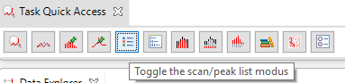
Peaks cannot be manipulated on the chromatogram. Go to (upper right window) to operate. Peak(s) can be selected to review or deleted (Note: only the peaks in the selected chromatogram range will be displayed).
V1.2 software: A peak can also be directly selected in the Chromatogram Editor by pressing Ctrl + double-click left mouse button.
Review peak mass spectrum: Add view

- Peak integration
First, go to “Window” >> “Preferences” to set parameters, such as ion’s m/z.
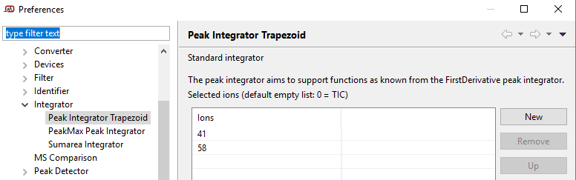
Then, go to “Chromatogram” >>
There are three integrators:
1) is the basic one. It can integrate TIC, or a list of selected ions.
2) obtains peak height (not area). Sometimes useful for overlapped peaks.
3) integrate the sum of all peak areas (only works in V 1.2 software)

Use “Ion Remover” filter to remove all ions but the wanted one(s). (In V 1.3 software, it’s only available by right click on chromatogram view. In V1.2 software, can be find in the filter menu.)

- Identify a compound with mass spectrum
1). Select the peak to be identified or double click on a point of the chromatogram. The corresponding mass spectrum should show in the view (lower middle).
2). Maximize the view. Then, click on 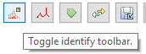. Before use the identifiers, go to Window >> Preferences to set parameters. The “File MS identifier” supports major companies’ MS spectrum libraries.
3). Click on the identify toolbar to manipulate the mass spectrum or search the library. After search, the results show in view (lower left).

- Report data
Go to “Chromatogram” >> “Reports” to save report.

- Selected ion chromatogram
Click on “Toggle the overlay modus” in the Task Quick Access window on top.
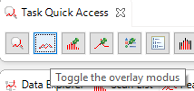
view will show up in the lower left window. Click on the “Toggle profile toolbar”, then select “SIC” or “TIC + SIC”.

In V 1.2 software: Set parameters on the “Option” tab in the Chromatogram view. Then, open Chromatogram Overlay (Selected ion) view to explore. The selected ions’ chromatograms can be magnified (not available in V 1.3 software).

- Overlay chromatograms
Open the chromatograms you want to overlay. Then, go to view. You may use “shift toolbar” 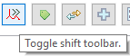to adjust the positions of the chromatograms.

